Read Text Extension on Ubuntu with LibreOffice
https://sites.google.com/site/readtextextension/home/linux

Ubuntu 11.04 has a problem using mbrola voices with espeak. The Pico speech synthesizer is a good alternative that speaks clearly. The pico speech description files are in binary format only, so unlike espeak, you can't edit the speech rules for localized pronunciation of particular words or place names.
The SVOX Pico speech synthesizer uses Hidden Markov Model (HMM) algorithms to produce clear speech output in the form of an audio file. It works with German, English, Spanish, French and Italian text. Read Text Extension now includes a python script to read the SVOX Pico audio file aloud using an audio or movie player.
The SVOX Pico speech synthesizer packages are available in Debian's non-free repository and in Ubuntu's multiverse repository. Use a package manager like Synaptic or apt-get to install the following packages:

libttspico0
libttspico-utils
libttspico-data

If you want to try it with Linux, and your distribution includes apt-get, use these commands to install it:

sudo apt-get install libttspico0 libttspico-utils libttspico-data

Other Linux distributions may make the SVOX Pico packages available with a different name. You need an up-to-date version of the Read Text Extension. Once you have installed the software, set up Read Text Extension's options with Tools - Add-ons - Read selection.... Use /usr/bin/python as the external program. Select a command line option that includes the token (PICO_READ_TEXT_PY).

Soy Wachín, yo le puse esto:
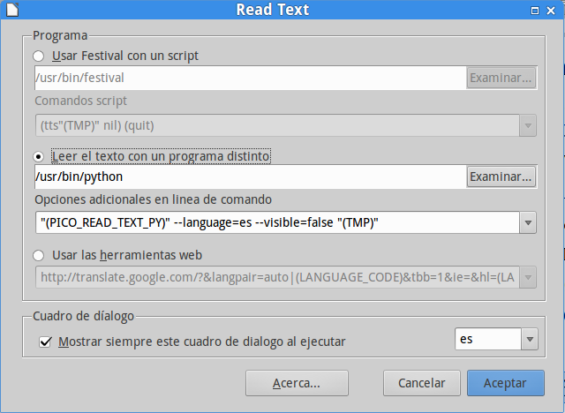

Respaldo del comando:

"(PICO_READ_TEXT_PY)" --language=(SELECTION_LANGUAGE_COUNTRY_CODE) --rate=75% --pitch=100% --visible=false "(TMP)"

